16.6 Polymers
Name: ____________________ Class: ____________________ Due date: 3.12
1. PVA is a polymer. The monomer has the structure shown.
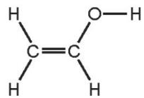
To which homologous series does this compound belong? （ ）
 | alcohols | alkenes
A | ✓ | ✓
B | ✓ | ×
C | × | ✓
D | × | ×

2. A hydrocarbon X is cracked to make Y and hydrogen. Compound Z is formed by the addition polymerisation of Y. To which homologous series do X, Y and Z belong?（ ）
 | alkane | alkene
A | X, Y and Z | -
B | X and Y | Z
C | X and Z | Y
D | Y and Z | X

4. Which row describes the formation of a polymer? （ ）
 | monomer | polymer
A | ethane | poly(ethane)
B | ethane | poly(ethene)
C | ethene | poly(ethane)
D | ethene | poly(ethene)

5. Which polymer structure has the same linkages as Terylene? （ ）
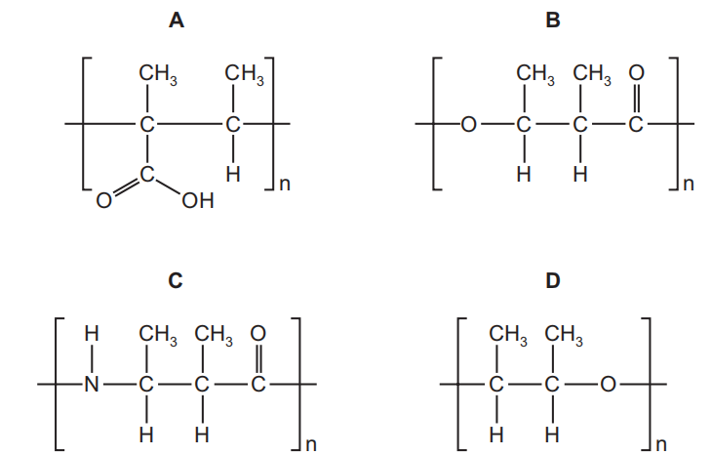

6. Propene is an unsaturated hydrocarbon. The formula of propene is shown.
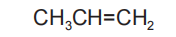
(i) Propene can be converted into poly(propene).
Name the type of polymerisation that occurs when propene is converted into poly(propene).
.......................................................................................................................................
(iv) Complete the diagram to show a section of poly(propene)

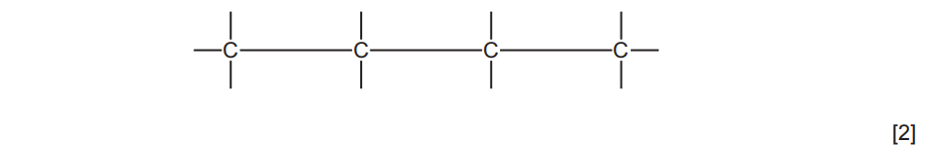
3.Ethene,${CH}_{2}={CH}_{2}$,and propene,${CH}_{2}={CHCH}_{3}$,can both be converted into polymers.
What type of polymerisation takes place when ethene forms a polymer?
.......................................................................................................................................
.................................................................................................................................[1]
ii.What is the empirical formula of the polymer formed from ethene?
..................................................................................................................................[1]
Propene has the structural formula ${CH}_{2}={CHCH}_{3}$ .
Draw two repeat units of the polymer made from propene.

[2]

